**Heart Disease Prediction Using Machine Learning Techniques**

Presented By:- Kushagra Pandey, Vansh Rajput, Gungun Pachauri

**Abstract:**

This study explores the detection of heart disease by implementing different machine learning algorithms. The research is structured in two stages: first, the heart disease dataset is formatted to be compatible with machine learning processes, using patient data sourced from the UCI repository. The dataset is then analyzed to identify heart disease presence among patients. In the second stage, the study evaluates various machine learning algorithms—Logistic Regression, Support Vector Machine, K-Nearest Neighbors, Random Forest, and Gradient Boosting Classifier—through accuracy testing with a confusion matrix. Findings show that Logistic Regression yields a high accuracy of 95%, surpassing other methods and excelling in f1-score, recall, and precision. Future research aims to increase these accuracy levels to a 97-100% range, which remains a challenging and ongoing goal​

## **Introduction**

In the medical field, ML’s role has become increasingly crucial, as the need for accurate and efficient disease diagnosis has grown alongside advancements in medical technology. Leveraging ML for healthcare applications enables the creation of sophisticated models that can identify potential health risks, streamline diagnostics, and even predict disease progression. Specifically, this study explores the potential of ML algorithms to enhance the early detection and prediction of heart disease, a leading cause of death globally. Heart disease diagnosis often relies on analyzing multiple risk factors—such as age, blood pressure, cholesterol levels, and lifestyle indicators. By employing ML, we can develop predictive models that help analyze these variables, allowing for more consistent and reliable diagnoses.

This research focuses on utilizing various ML techniques to evaluate and classify heart disease risk in patients. It aims to improve diagnostic consistency and accuracy by applying a structured approach to data analysis. The study examines how algorithms like Logistic Regression, Support Vector Machine (SVM), K-Nearest Neighbors (KNN), Random Forest, and Gradient Boosting Classifier can process patient data and identify patterns associated with heart disease. By building a predictive model, this research seeks to provide a framework that medical professionals can use to supplement their assessments and potentially catch heart disease cases earlier, thereby improving treatment outcomes and reducing the overall impact on patients' health.

**2.Methodology**

* The methodology for this study includes multiple stages, from data collection and preparation to the application and evaluation of machine learning models. Each stage is carefully structured to ensure accurate, reliable predictions of heart disease risk among patients. Below is an outline of the steps taken in this research to implement and test various machine learning algorithms.
* **1. Data Collection**

The first step in this methodology involves gathering data from credible sources, with the heart disease dataset sourced from the UCI Machine Learning Repository. This dataset contains multiple patient attributes, including age, gender, blood pressure, cholesterol levels, and other relevant medical indicators, which are critical for assessing heart disease risk. These records provide a solid foundation for training and testing machine learning models in a controlled, data-rich environment.

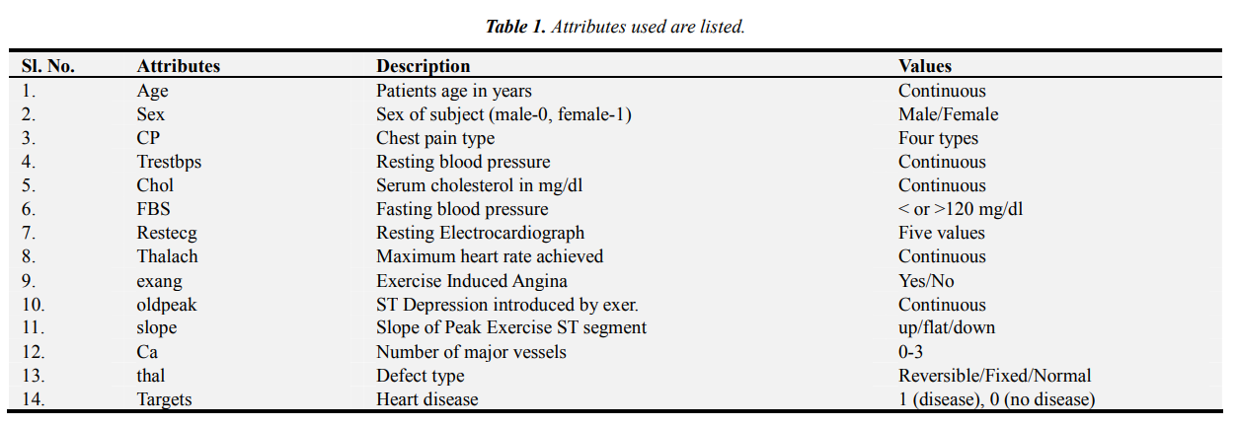

* **2. Data Preprocessing**

Preprocessing is essential to clean and prepare the dataset, as raw data often contains inconsistencies, missing values, and noise that can skew model accuracy. During preprocessing, any incomplete or irrelevant data points are addressed, and attributes are transformed into a suitable format for machine learning algorithms. Data normalization, smoothing, and encoding categorical variables are applied to ensure that all data points align with the algorithms’ requirements, thereby optimizing the models' learning process.

* **3. Data Splitting and Balancing**

To enhance model reliability, the dataset is split into two main subsets: a training set and a testing set. Typically, 80% of the data is used for training, with the remaining 20% reserved for testing, allowing the models to learn patterns and validate their predictions. Additionally, techniques like oversampling or undersampling are applied if the data is imbalanced (i.e., if there is a disproportionate number of cases with or without heart disease), as balanced data improves model performance and prediction stability.

* **4. Feature Selection**

Selecting the most relevant features from the dataset is crucial for maximizing model accuracy and computational efficiency. A correlation matrix is used to identify attributes that have a strong or weak relationship with heart disease outcomes. Key features, such as age, chest pain type, serum cholesterol, and resting blood pressure, are prioritized based on their statistical correlation with the target outcome. This step reduces unnecessary complexity and helps the models focus on the most informative attributes, improving overall prediction accuracy.

* **5. Model Selection and Implementation**

Five machine learning algorithms are selected for this study: Logistic Regression, Support Vector Machine (SVM), K-Nearest Neighbours (KNN), Random Forest, and Gradient Boosting Classifier and other . These algorithms are chosen for their effectiveness in classification tasks and their ability to handle non-linear and complex relationships within data. Each algorithm is trained on the heart disease dataset, allowing the model to learn from the training data and refine its predictions.

* **6. Model Evaluation**

To assess the performance of each model, metrics such as accuracy, precision, recall, and F1-score are calculated. A confusion matrix is used to measure these metrics, as it provides a detailed breakdown of true positive, true negative, false positive, and false negative rates. Logistic Regression, in particular, is expected to demonstrate high accuracy, which will be verified through comparison with the other models. This evaluation process highlights each model's strengths and limitations, providing a clear indication of which approach best predicts heart disease within this dataset.

* **7. Comparative Analysis and Optimization**

After evaluating the initial model outcomes, a comparative analysis of the algorithms is conducted. By examining the accuracy rates, error rates, and computational efficiency of each model, this study identifies the algorithm that offers the highest predictive performance. In cases where accuracy needs improvement, hyperparameter tuning and cross-validation techniques are employed to refine model settings, enhancing prediction quality and reliability.

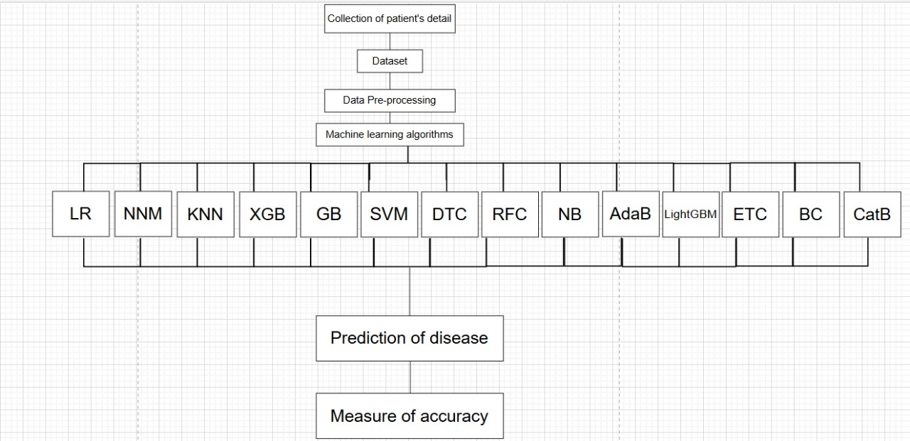

# **3.Machine Learning Algorithms**

A data analysis technique called machine learning automates the development of analytical models. In this observation, five different algorithms are studied to obtain the accuracy for finding the best one.

**3.1 Logistic Regression-**

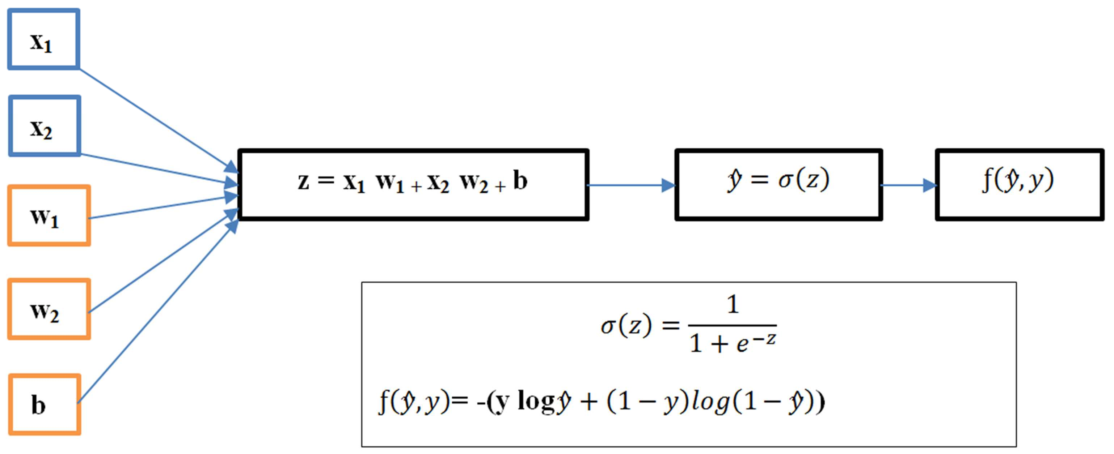

Logistic Regression is a classification algorithm commonly used to predict binary outcomes (e.g., disease presence or absence). It works by modeling the probability of a certain class or event, often using a sigmoid function to map predictions to probabilities between 0 and 1.

We get : Accuracy on Training data **: 0.852** , Accuracy on Test data : **0.804** on our model

**3.2 Neural Networks Model-**

Neural networks are inspired by the structure of the human brain, with layers of interconnected "neurons" that process data inputs. They can detect complex patterns within data by transforming inputs through multiple hidden layers, which makes them powerful for handling non-linear relationships.

We get: Accuracy on Training data**: 0.831**, Accuracy on Test data: **0.780** on our model

**3.3 K-Nearest Neighbor-**

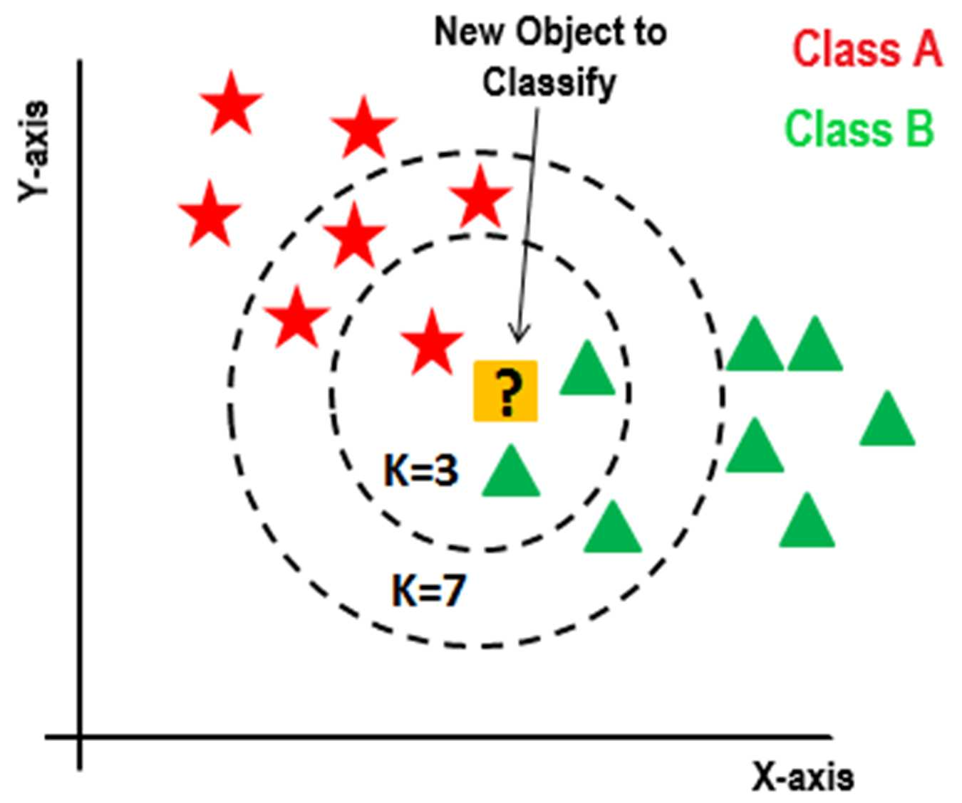

KNN is a simple, instance-based learning algorithm that classifies data points based on the majority label of their closest neighbors.

We get : Accuracy on Training data **: 0.754** , Accuracy on Test data : **0.687** on our model

**3.4 XGboost(Extreme Gradient Boosting)-**

XGBoost is a powerful boosting algorithm that improves prediction accuracy by building models sequentially and correcting previous models' errors. Known for its efficiency and speed

We get : Accuracy on Training data **: 0.917** , Accuracy on Test data : **0.882** on our model

**3.5 Gradient Boosting Classifier-**

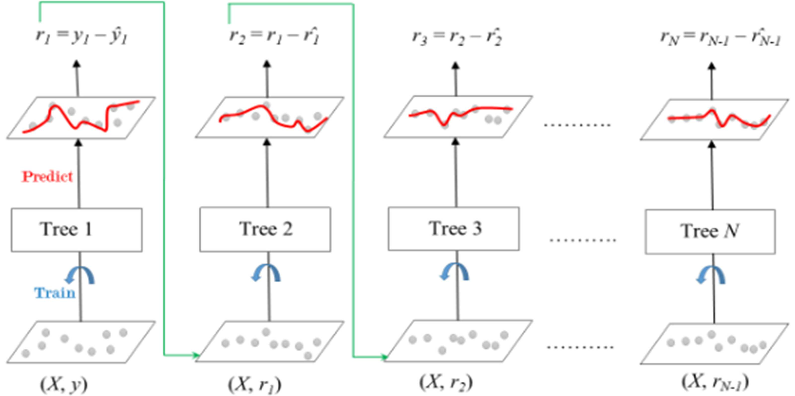

Gradient Boosting Classifier is a boosting method that creates multiple decision trees in sequence, each correcting the errors of the previous ones. This approach makes it effective for capturing complex data patterns.

We get : Accuracy on Training data **: 0.987** , Accuracy on Test data : **0.985** on our model

**3.6 Support Vector Machine-**

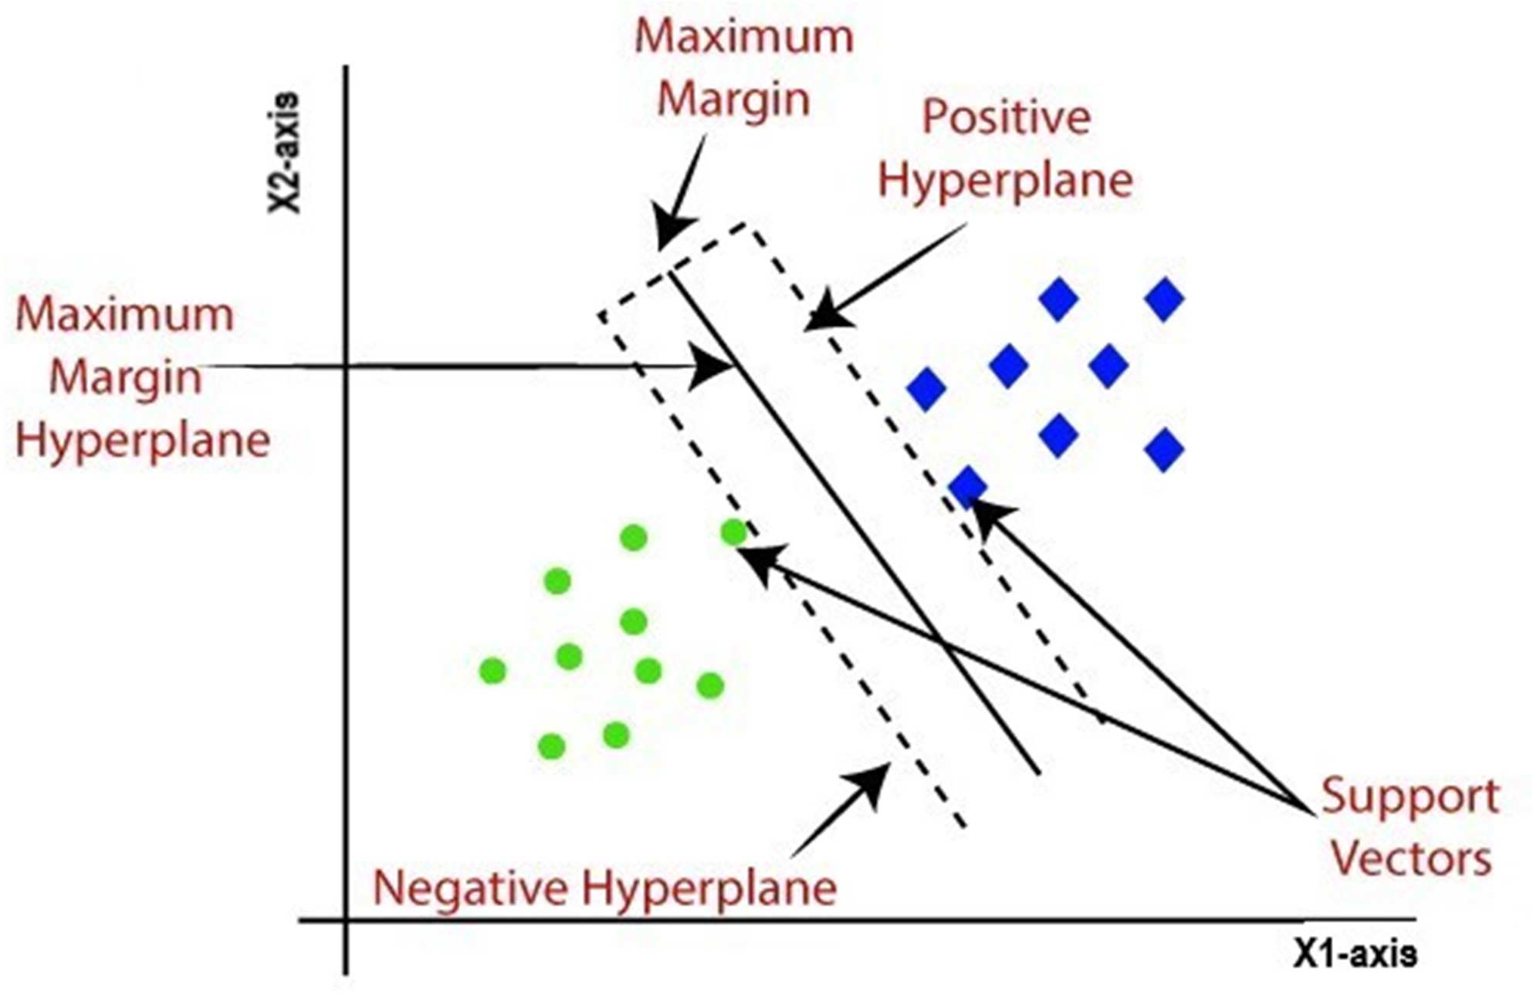

SVM is a classification algorithm that works by finding the optimal hyperplane that separates different classes in the data. This separation maximizes the margin between data points, enhancing prediction accuracy.

We get : Accuracy on Training data **: 0.720**, Accuracy on Test data : **0.707** on our model

**3.7 Decision Tree Classifier-**

The Decision Tree Classifier splits data into branches based on feature values, leading to a tree structure that helps classify outcomes.

We get : Accuracy on Training data **: 0.936** , Accuracy on Test data : **0.882** on our model

**3.8 Random Forest classifier-**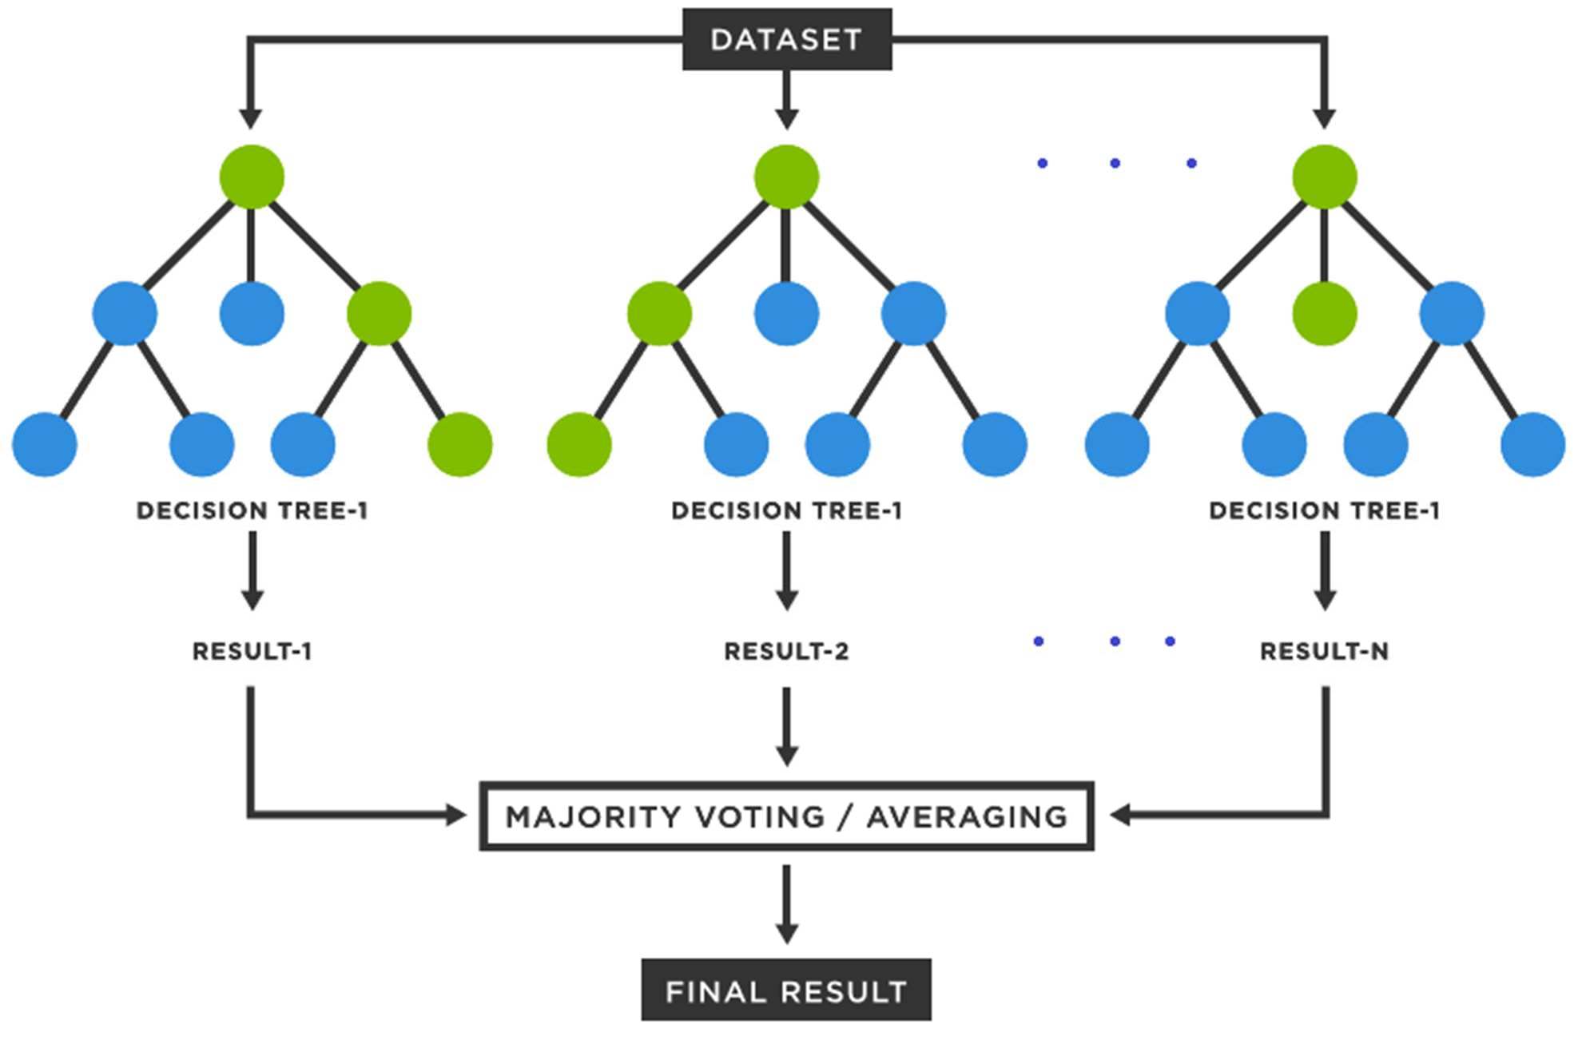

Random Forest combines multiple decision trees to improve prediction stability and accuracy. Each tree in the "forest" votes on the outcome, and the majority vote becomes the model's prediction. This ensemble method reduces overfitting, which is beneficial for handling variability in medical datasets like those used for heart disease prediction.

We get : Accuracy on Training data **: 0.995** , Accuracy on Test data : **0.990** on our model

**3.9 Naive Bays-**

Naive Bayes is a probabilistic classifier based on Bayes’ Theorem, assuming that features are independent. Despite this simplifying assumption, Naive Bayes often performs well in practice, especially on text-based or categorical data. In disease prediction, it can quickly process large datasets and provide probabilistic outcomes.

We get : Accuracy on Training data **: 0.839** , Accuracy on Test data : **0.780** on our model

**3.10 AdaBoost-**

AdaBoost is another boosting algorithm that focuses on correcting the errors of prior models, but it does so by assigning more weight to misclassified instances.

We get : Accuracy on Training data **: 0.912** , Accuracy on Test data : **0.868** on our model

**3.11 Light Gradient Boosting Machine-**

LightGBM is a gradient-boosting framework optimized for speed and efficiency. It splits data in a way that significantly reduces training time while maintaining accuracy.

We get : Accuracy on Training data **: 1.0** , Accuracy on Test data : **1.0** on our model

**3.12 Extra Trees Classifier-**

An ensemble method that uses multiple, fully randomized decision trees for higher variance reduction, leading to better accuracy and faster training.

We get : Accuracy on Training data **: 0.997** , Accuracy on Test data : **0.995** on our model

**3.13 Bagging classifier-**

An ensemble technique that combines predictions from multiple base estimators (usually decision trees) trained on random subsets of data to reduce overfitting.

We get : Accuracy on Training data **: 1.0** , Accuracy on Test data : **0.985** on our model

**3.15 Catboost-**

A gradient boosting algorithm designed for categorical features, providing high accuracy, fast training, and robust handling of categorical data without extensive preprocessing.

We get : Accuracy on Training data **: 1.0** , Accuracy on Test data : **1.0** on our model

# **4. Result Analysis**

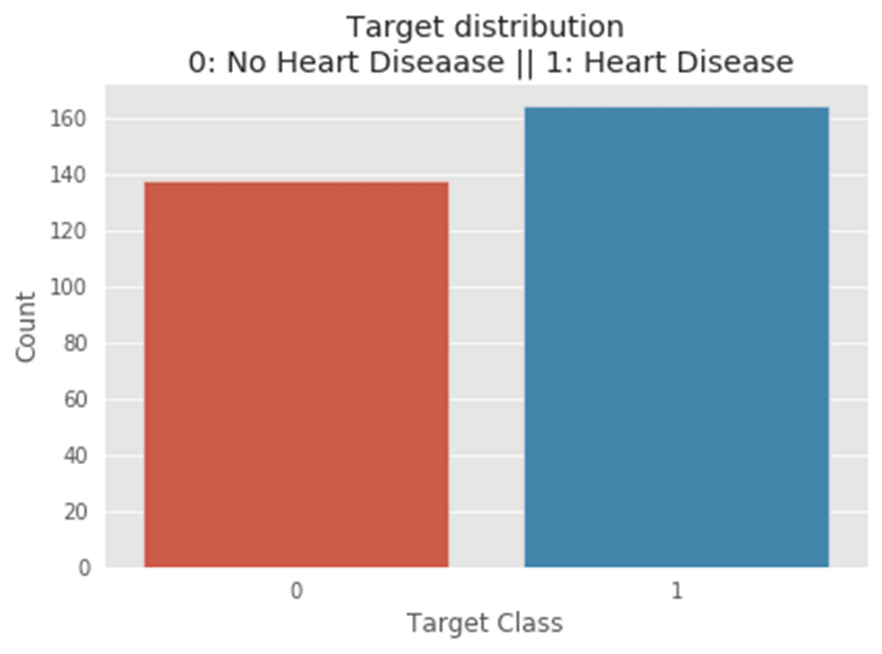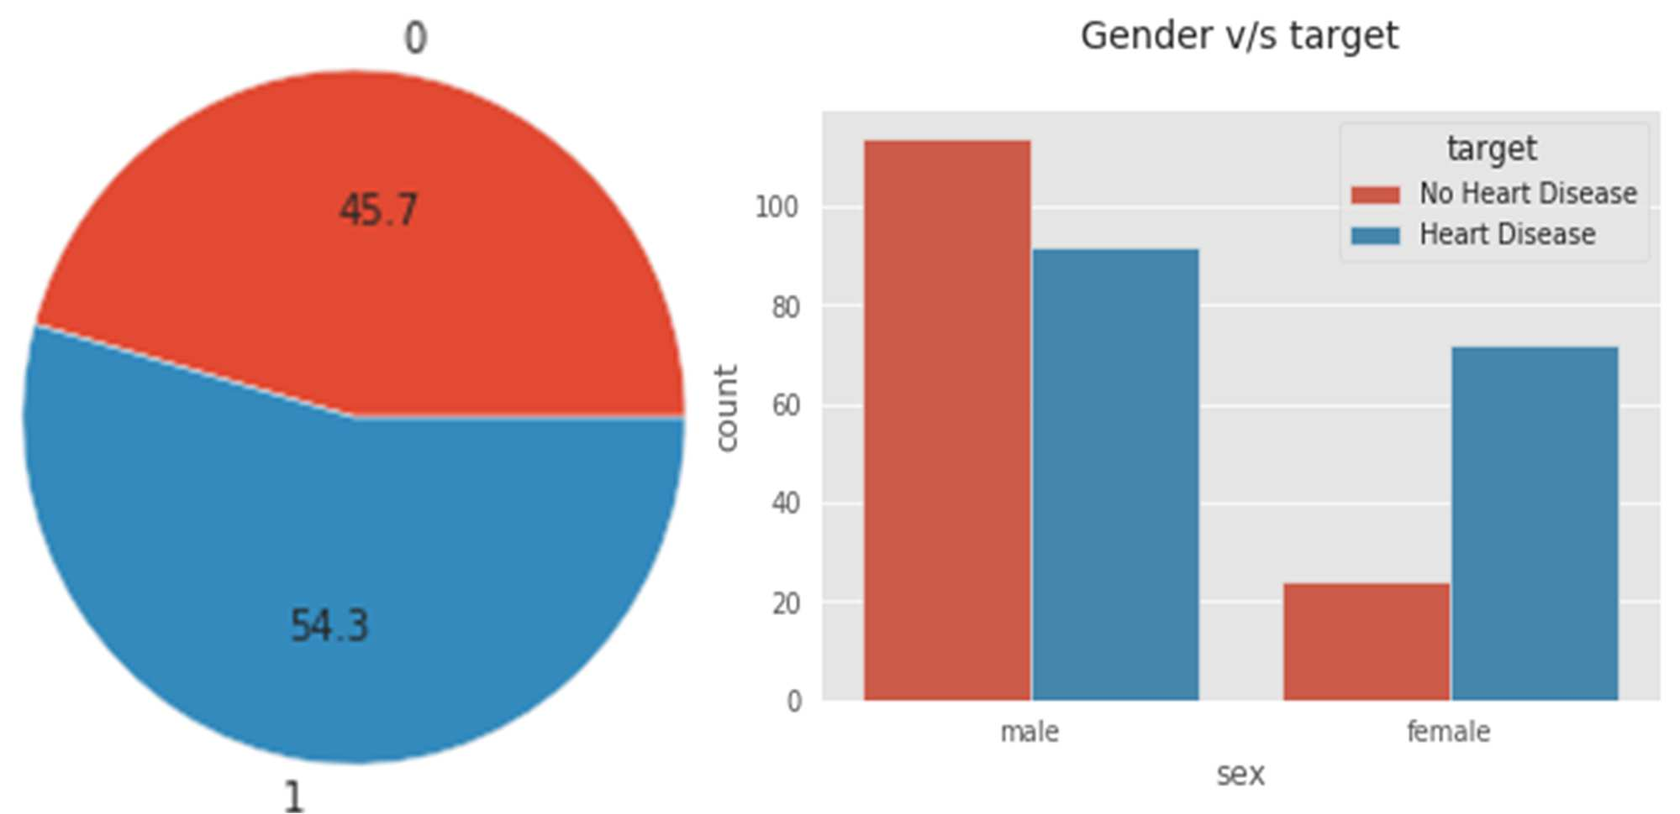**4.1 Analysis of Heart Diease Dataset**

Before going to study the performance of considering machine learning algorithms in this research, analysis of the features of the heart disease dataset will be focused on here. The total number of observations in the target attributes is 1025, where not having heart disease 499 (denoted by 0) and having heart disease 526 (represented by 1). So, the percentage of not having heart disease is 45.7%, and the percentage of having heart disease is 54.3%. It is shown that the rate of heart disease is more than the rate of no heart disease.

*(a) Age v/s Cholesterol with the target feature, (b) Kernel density estimate (kde) plot of age v/s cholesterol.*

It is shown that the rate of heart disease is more than the rate of no heart disease. T he sex feature of the HD dataset is observed through the target feature. In sex attribute, the female and male numbers are 312 and 713, respectively. So, the male number is more than double of female number. We can see that the number of heart diseases in males is higher than in females. Similarly, no heart disease among males is higher than in females.

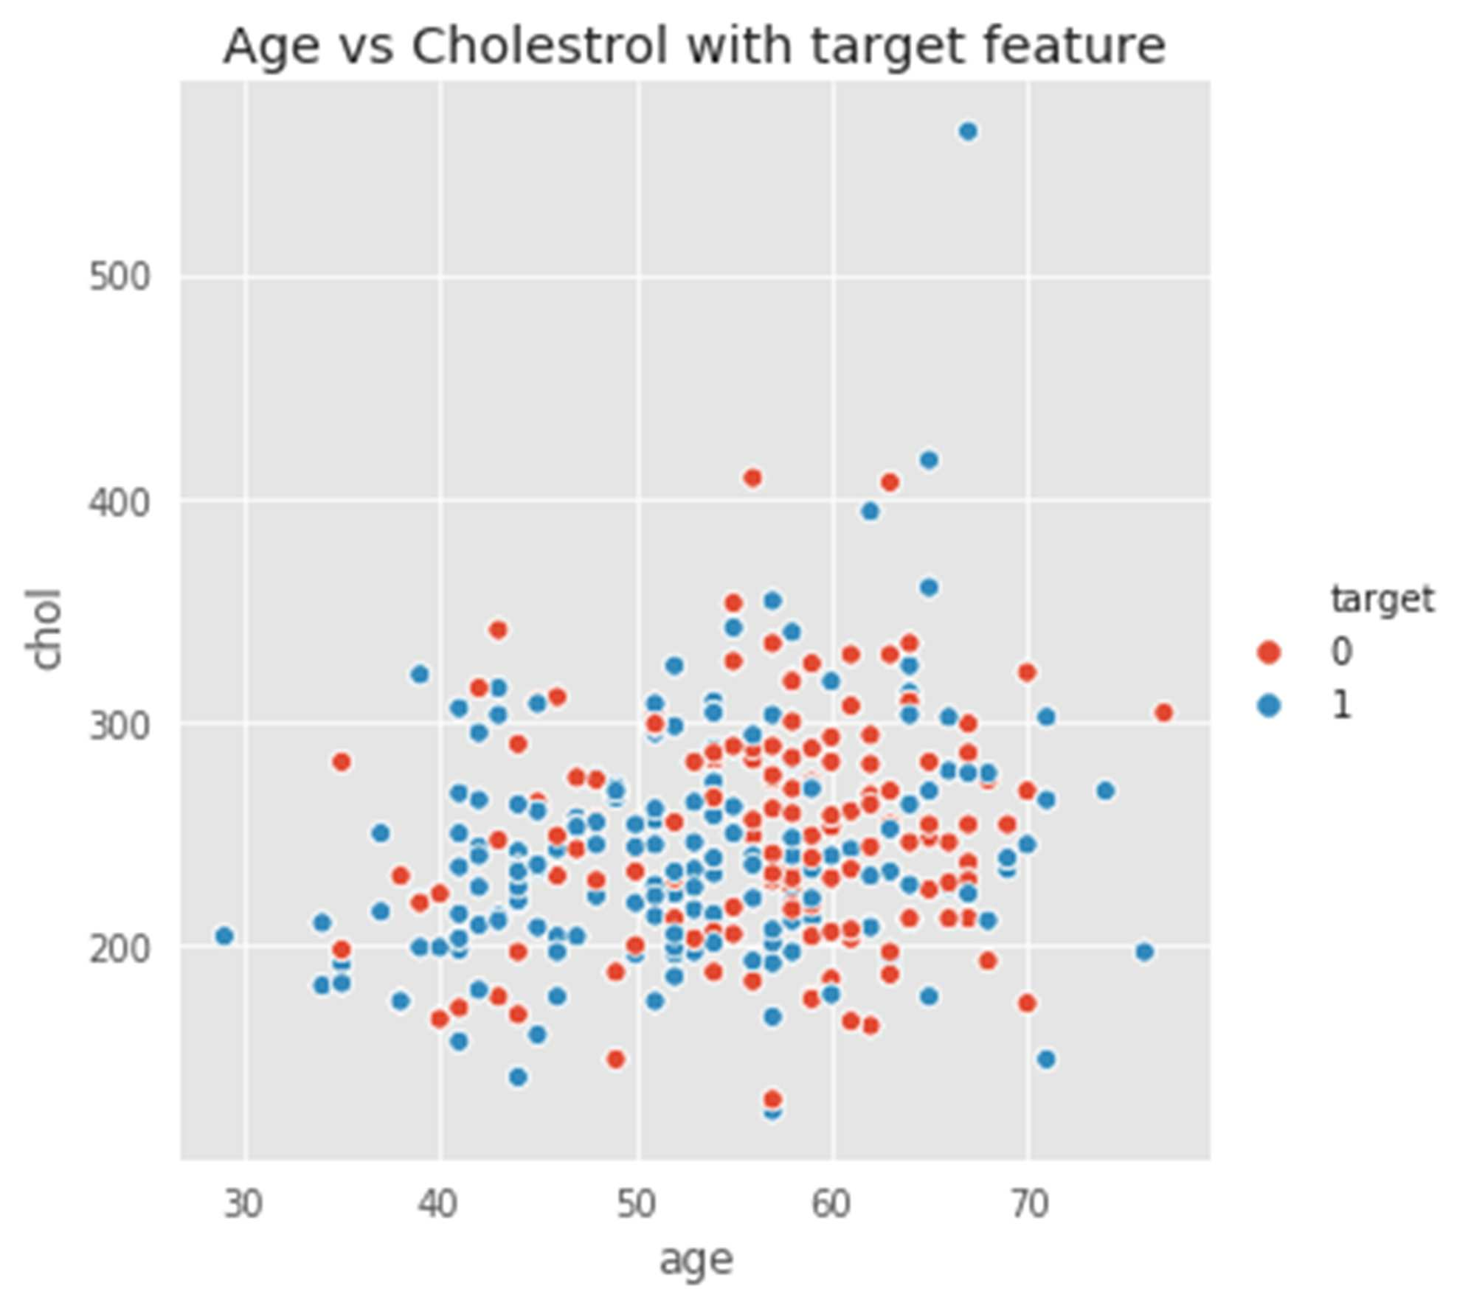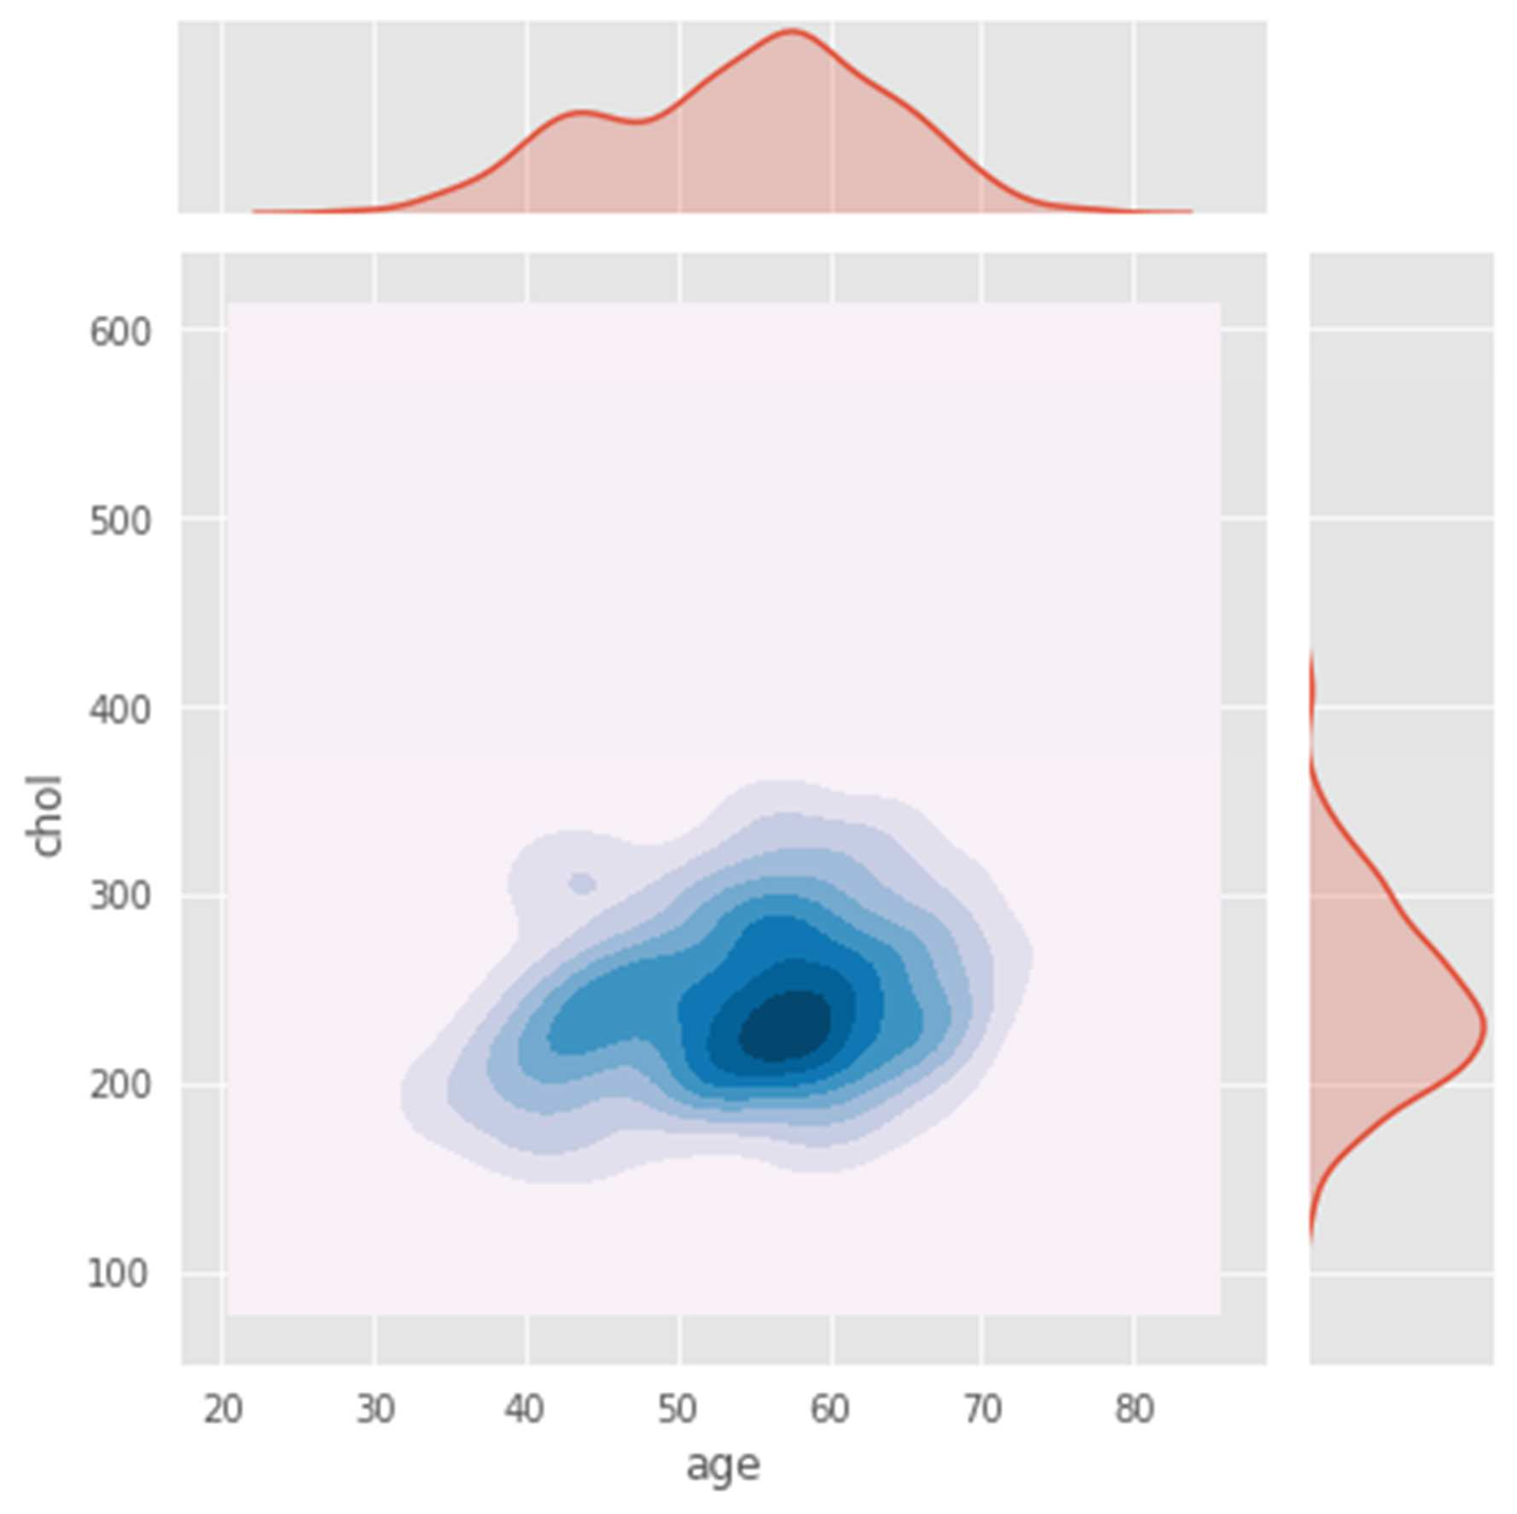

For an experiment, these features from the dataset are considered randomly. The trend of no heart disease is higher from 55 to 68 when the cholesterol level is between 200 mg/dl and 300 mg/dl.

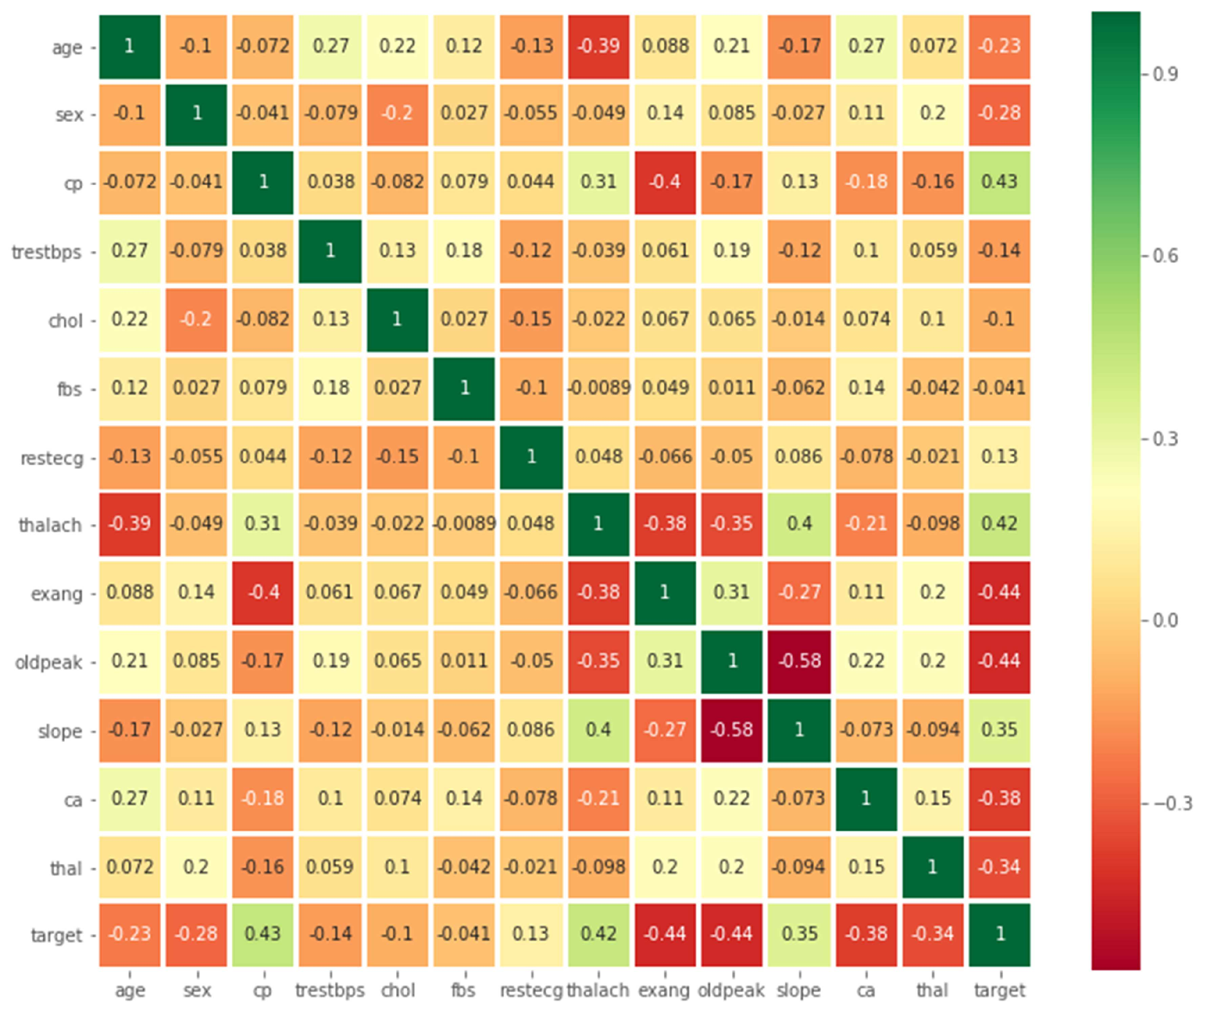

The correlation of the features is drawn in figure. The main purpose of the correlation plot is to define the positive and negative correlation between the features. However, it assumes that figure is complex for getting the strong and weak correlation. For this reason, this article added another figure to obtain these correlations efficiently. In figure, we can see that three features like cp, thalach, and slope positively correlate with target features.

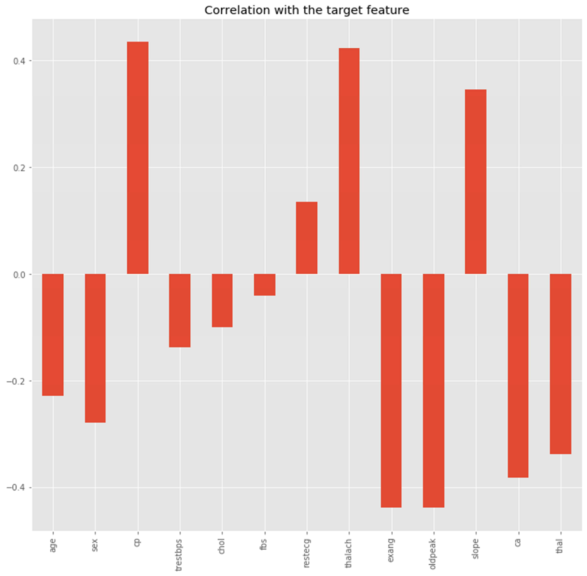

**4.2 Performance Analysis**

In this article, various machine learning algorithms like Logistic Regression (LR), Support vector machine (SVM), k- Nearest-Neighbors (KNN), Random Forest Classifier (RF), and Gradient Boosting Classifier (GBC) are studied broadly to predict the heart disease. The accuracy rate of each algorithm has been measured, and selects the algorithm with the highest accuracy. The accuracy rate is a correct prediction ratio to the total number of given datasets. It can be written as,

$$Accuracy=\frac{TP+TN}{TP+FP+FN+TN}$$

Where, TP: True Positive , TN: True Negative

FP: False Positive FN, False Negative

### After performing the machine learning algorithms for training and testing the dataset, we can find the better algorithm by considering the accuracy rate. The rate of accuracy is calculated with the support of a confusion matrix.

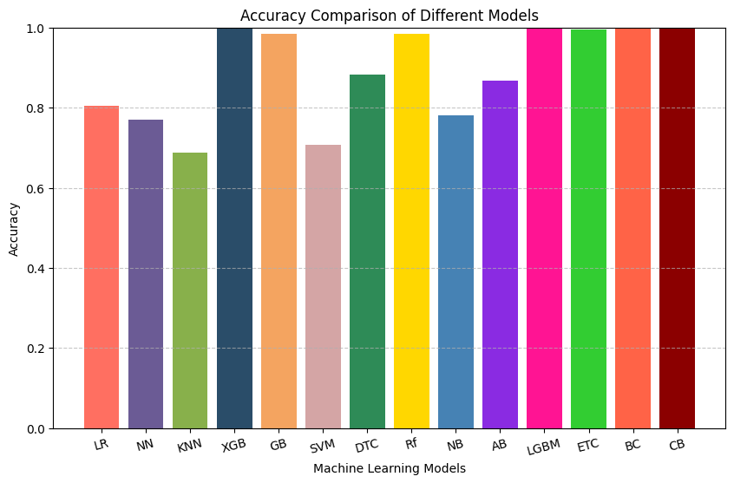

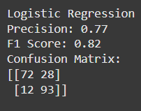 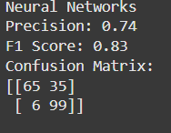 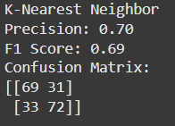

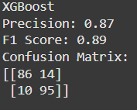 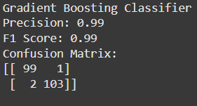 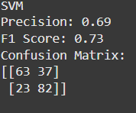

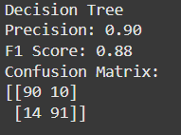 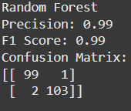 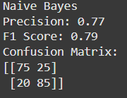

# **5. Conclusion and Future scope**

The heart is a vital organ in the human body; however, heart disease is a major concern in the world because this disease is increasing day by day. So, we can handle this disease if we have a model which can predict the initial condition of heart disease. So, we need to create a machine learning model that can be more accurate and help to diagnose heart disease with less doubt and cost. It can be a primary technique for knowing the condition of the heart. For this reason, this article focuses on the heart disease prediction based on the accuracy rate of the confusion matrix. Following this idea, the statistics of the given algorithms are used to estimate the accuracy rate of confusion matrix and validated the statistics among the machine learning algorithms. When five algorithms are compared, it is found that Logistic Regression algorithm is selected regarding the performance of high accuracy rate. The accuracy rate of Logistic Regression model is 95%, which indicates that machine learning algorithm will be considered as a pre- defined tool to seek heart diseases in the near future. Other statistics such as f1-score, recall, and precision rate have been calculated for Logistic Regression as 95%, 95%, and 95%, respectively. These estimated values suggest the highest accuracy of this algorithm.

These findings suggest that machine learning algorithms can effectively learn about the disease predictions. We may extend this kind of study to diagnose other diseases. We may also analyze the past history of data and combine other machine learning techniques for better study. Other possible further applications of this study can include such as, cardiovascular disease prediction, diabetic prediction, breast cancer prediction, tumor prediction, and multiple disease predictions.

# **Literature Review**

|  |  |  |  |  |
| --- | --- | --- | --- | --- |
| **Study** | **Model** | **Method** | **Evaluation Metrics** | **Score/Outcome** |
| [Chang et al., 2022](https://doi.org/10.1016/j.health.2022.100016) | AI Model | Machine Learning for Heart Disease | Accuracy, Precision | High Accuracy |
| Ghumbre & Ghatol, 2012 | Various ML Algorithms | Heart Disease Diagnosis | Accuracy, Sensitivity | N/A |
| [Bharti et al., 2021](https://doi.org/10.1155/2021/8387680) | ML & DL Hybrid | Prediction using ML & DL Combination | AUC, Accuracy | High AUC |
| [Almustafa, 2020](https://doi.org/10.1186/s12859-020-03626-y) | Various Classifiers | Sensitivity Analysis | Sensitivity, Specificity | Improved Sensitivity |
| Jee et al., 2014 | Logistic Regression | Korean Heart Study Model | Accuracy,  Precision,  Recall | Good Predictive Power |
| Shouman et al., 2012 | KNN | Diagnosis using KNN | Accuracy,  Precision,  Recall | Moderate Accuracy |
| Ganna et al., 2013 | Genetic Risk Scores | Multilocus Genetic Risk Assessment | Risk Prediction Accuracy | Improved Risk Assessment |
| Raihan et al., 2016 | Data Mining | Smartphone-based Risk Prediction | Accuracy, Precision | Prototype Developed |
| Acharya et al., 2017 | CNN | ECG Signal Analysis | Accuracy,  Precision,  Recall | High AUC |
| Takci, 2018 | Feature Selection Methods | Heart Attack Prediction | Accuracy, Precision | Improved Accuracy |
| Brown et al., 1997 | Statistical Analysis | Heart Attack Register Data Analysis | Mortality Rate Analysis | Historical Insights |
| Soni et al., 2011 | Data Mining | Medical Diagnosis for Heart Disease | Accuracy, Specificity | Overview |
| Bashir et al., 2014 | Ensemble Methods | Decision Support Framework | Accuracy, F1-Score | High Accuracy |
| Ordonez, 2006 | Association Rule Discovery | Train-Test Approach for Heart Disease | Precision, Recall | Rule-based Insights |
| [Wikipedia, 2022](https://en.wikipedia.org/w/index.php?title=Logistic_regression&oldid=1094256072) | Logistic Regression | Overview of Logistic Regression | N/A | Conceptual Understanding |
| [Wikipedia, 2022](https://en.wikipedia.org/w/index.php?title=Linear_regression&oldid=1091044459) | Linear Regression | Overview of Linear Regression | N/A | Conceptual Understanding |
| [Wikipedia, 2022](https://en.wikipedia.org/w/index.php?title=K-nearest_neighbors_algorithm&oldid=1091525121) | K-Nearest Neighbors | Overview of KNN Algorithm | N/A | Conceptual Understanding |
| [Wikipedia, 2022](https://en.wikipedia.org/w/index.php?title=Random_forest&oldid=1094130824) | Random Forest | Overview of Random Forest Algorithm | N/A | Conceptual Understanding |
| [Wikipedia, 2022](https://en.wikipedia.org/w/index.php?title=Decision_tree_learning&oldid=1093316444) | Decision Tree | Overview of Decision Tree Learning | N/A | Conceptual Understanding |
| [Wikipedia, 2022](https://en.wikipedia.org/w/index.php?title=Gradient_boosting&oldid=1094845596) | Gradient Boosting | Overview of Gradient Boosting | N/A | Conceptual Understanding |
| [Wikipedia, 2022](https://en.wikipedia.org/w/index.php?title=Support-vector_machine&oldid=1094109362) | SVM | Overview of Support Vector Machines | N/A | Conceptual Understanding |
| [nikki2398, 2020](https://www.geeksforgeeks.org/ml-gradient-boosting/) | Gradient Boosting | Overview of Gradient Boosting Techniques | N/A | Educational Resource |

# **References**

•Wikipedia contributors, "Machine learning," *Wikipedia, The Free Encyclopedia*, Jun. 22, 2022. [Online]. Available: <https://en.wikipedia.org/w/index.php?title=Machine_learning&oldid=1094363111>. [Accessed: Jun. 26, 2022].

• V. Chang, V. R. Bhavani, A. Q. Xu, and M. A. Hossain, "An artificial intelligence model for heart disease detection using machine learning," *Healthcare Analytics*, vol. 2, p. 100016, Nov. 2022. doi: [10.1016/j.health.2022.100016](https://doi.org/10.1016/j.health.2022.100016).

•S. U. Ghumbre and A. A. Ghatol, "Heart disease diagnosis using machine learning algorithm," in *Proceedings of the International Conference on Information Systems Design and Intelligent Applications 2012 (INDIA 2012)*, Visakhapatnam, India, Jan. 2012, pp. 217-225. Springer, Berlin, Heidelberg.

•R. Bharti, A. Khamparia, M. Shabaz, G. Dhiman, S. Pande, and P. Singh, "Prediction of Heart Disease Using a combination of Machine Learning and Deep Learning," *Hindawi Computational Intelligence and Neuroscience*, vol. 2021, Article ID 8387680, 11 pages, 2021. doi: [10.1155/2021/8387680](https://doi.org/10.1155/2021/8387680).

•K. M. Almustafa, "Prediction of heart disease and classifiers sensitivity analysis," *BMC Bioinformatics*, vol. 21, p. 278, 2020. doi: [10.1186/s12859-020-03626-y](https://doi.org/10.1186/s12859-020-03626-y).

• S. H. Jee, Y. Jang, D. J. Oh, B. H. Oh, S. H. Lee, S. W. Park, and Y. D. Yun, "A coronary heart disease prediction model: The Korean Heart Study," *BMJ Open*, vol. 4, no. 5, e005025, 2014.

•M. Shouman, T. Turner, and R. Stocker, "Applying k-Nearest Neighbour in diagnosis heart disease patients," *International Journal of Information and Education Technology*, vol. 2, no. 3, pp. 220-223, Jun. 2012.

•A. Ganna, P. K. Magnusson, N. L. Pedersen, U. de Faire, M. Reilly, J. Arnlov, and E. Ingelsson, "Multilocus genetic risk scores for coronary heart disease prediction," *Arteriosclerosis, Thrombosis, and Vascular Biology*, vol. 33, no. 9, pp. 2267-2272, 2013.

• M. Raihan, S. Mondal, A. More, M. O. F. Sagor, G. Sikder, M. A. Majumder, and K. Ghosh,

"Smartphone-based ischemic heart disease (heart attack) risk prediction using clinical data and data mining approaches, a prototype design," in *19th International Conference on Computer and Information Technology (ICCIT)*, Dec. 2016, pp. 299-303. IEEE.

• U. R. Acharya, H. Fujita, S. L. Oh, Y. Hagiwara, J. H. Tan, and M. Adam, "Application of deep convolutional neural network for automated detection of myocardial infarction using ECG signals," *Information Sciences*, vol. 415, pp. 190-198, 2017.

•H. Takci, "Improvement of heart attack prediction by the feature selection methods," *Turkish Journal of Electrical Engineering & Computer Sciences*, vol. 26, no. 1, pp. 1-10, 2018.

• N. Brown, T. Young, D. Gray, A. M. Skene, and J. R. Hampton, "Inpatient deaths from acute myocardial infarction, 1982-92: analysis of data in the Nottingham heart attack register," *BMJ*, vol. 315, no. 7101, pp. 159-164, 1997.

•J. Soni, U. Ansari, D. Sharman, and S. Soni, "Predictive data mining for medical diagnosis: an overview of heart disease prediction," *International Journal of Computer Applications*, vol. 17, no. 8, pp. 43-48, 2011.

•S. Bashir, U. Qamar, and M. Y. Javed, "An ensemble-based decision support framework for intelligent heart disease diagnosis," in *International Conference on Information Society (i-Society 2014)*, Nov. 2014, pp. 259-264. IEEE.

• C. Ordonez, "Associate rule discovery with the train and test approach for heart disease prediction," *IEEE Transactions on Information Technology in Biomedicine*, vol. 10, no. 2, pp. 334-343, 2006.

•Wikipedia contributors, "Logistic regression," *Wikipedia, The Free Encyclopedia*, Jun. 21, 2022. [Online]. Available: <https://en.wikipedia.org/w/index.php?title=Logistic_regression&oldid=1094256072>. [Accessed: Jun. 26, 2022].

•Wikipedia contributors, "Linear regression," *Wikipedia, The Free Encyclopedia*, Jun. 1, 2022. [Online]. Available: <https://en.wikipedia.org/w/index.php?title=Linear_regression&oldid=1091044459>. [Accessed: Jun. 26, 2022].

•Wikipedia contributors, "K-nearest neighbors algorithm," *Wikipedia, The Free Encyclopedia*, Jun. 4, 2022. [Online]. Available: <https://en.wikipedia.org/w/index.php?title=K-nearest_neighbors_algorithm&oldid=1091525121>. [Accessed: Jun. 26, 2022].

•Wikipedia contributors, "Random forest," *Wikipedia, The Free Encyclopedia*, Jun. 20, 2022. [Online]. Available: <https://en.wikipedia.org/w/index.php?title=Random_forest&oldid=1094130824>. [Accessed: Jun. 26, 2022].

•Wikipedia contributors, "Decision tree learning," *Wikipedia, The Free Encyclopedia*, Jun. 15, 2022. [Online]. Available: <https://en.wikipedia.org/w/index.php?title=Decision_tree_learning&oldid=1093316444>. [Accessed: Jun. 26, 2022].

•Wikipedia contributors, "Gradient boosting," *Wikipedia, The Free Encyclopedia*, Jun. 24, 2022. [Online]. Available: <https://en.wikipedia.org/w/index.php?title=Gradient_boosting&oldid=1094845596>. [Accessed: Jun. 26, 2022].

•nikki2398, "ML–Gradient Boosting," GeeksforGeeks, Sep. 2, 2020. [Online]. Available: <https://www.geeksforgeeks.org/ml-gradient-boosting/>. [Accessed: Jun. 26, 2022].

•Wikipedia contributors, "Support-vector machine," *Wikipedia, The Free Encyclopedia*, Jun. 20, 2022. [Online]. Available: <https://en.wikipedia.org/w/index.php?title=Support-vector_machine&oldid=1094109362>. [Accessed: Jun. 26, 2022].